

Syncope OpenSource IdM
Managing Identities in Enterprise Environments
Version 1.0 / 2011-01-26


Syncope OpenSource IdM by http://syncope.googlecode.com/ is licensed under a Creative Commons Attribution 3.0 License. To view a copy of this license, visit http://creativecommons.org/licenses/by-sa/3.0/
Table of Contents
1 Executive summary 3
2 Requirements for an effective Identity Infrastructure 4
2.1 Identity Lifecycle Management 5
3 Syncope, Open Source IdM 7
3.1 Why Open Source 7
3.2 High-level Architecture 8
3.2.1 Syncope core logic 9
3.2.2 RESTful controllers 9
3.2.3 Workflow engine 9
3.2.4 JPA persistence layer 9
3.2.5 IdentityConnectors propagation layer 9
3.3 Console walk-through 10
4 Some achievements 21

List of Figures
Figure 1: No IAM organization 4
Figure 2: IAM-enabled organization 5
Figure 3: Identity Lifecycle 6
Figure 4: High-level Syncope architecture 8
Figure 5: Console: welcome screen 10
Figure 6: Console: schema editing 11
Figure 7: Console: derived schemas 12
Figure 8: Console: user attribute editing 13
Figure 9: Console: user resource editing 13
Figure 10: Console: user role editing (memberships) 14
Figure 11: Console: user search 14
Figure 12: Console: role attribute editing 15
Figure 13: Console: role resource editing 15
Figure 14: Console: role entitlement editing 16
Figure 15: Console: connector general editing 17
Figure 16: Console: connector capability editing 17
Figure 17: Console: target resource editing (schema mapping) 18
Figure 18: Console: task list 19
Figure 19: Console: task detail 20
Figure 20: Console: runtime parameter configuration 20

Executive summary
Identity management (or IdM) represents the joint result of business process and IT to manage user data on systems and applications. IdM involves considering user attributes, roles, resources and entitlements in trying to give a decent answer to the question bumping at every time in IT administrators' mind:
Who has access to What, When, How, and Why?

Inside a given organization, an IdM solution will basically
- provide the right information and tools to the right people, at the right time;
- enable approval process and delegation of authority;
- protect IT infrastructure from information theft;
- help the organization to comply with regulations;
- ensure the privacy of customer, partner and employee information;
- facilitate the creation and automate the enforcement of business policies that strengthen security, reduce administration costs and improve productivity.
Conversely, when not implementing an IdM solution, an organization can easily fall into situations in which, for example, new-hired and promoted employees sit idle waiting for granted access to needed tools while former employees can continue to have access for days and weeks after they left the organization. Moreover, compliance process cannot rely upon a verifiable, accurate and timely control over the identities of the people and resources distributed across the organization itself.

This paper introduces a new approach to build and maintain the identity management infrastructure by leveraging the fresh and rising IdM Open Source product called Syncope. In the following, this paper will examine what is required of an identity infrastructure today and introduce Syncope specifications, architecture and technicalities.

Requirements for an effective Identity Infrastructure
Building an identity infrastructure means often taking care of two distinct but tightly related aspects in IT management: identity management and access management; for this reason the preferred term to be used in this context is IAM (Identity and Access Management).
A complete IAM solution provides:
- identity lifecycle management (with workflow-based provisioning)
- meta-directory
- access control
- role-based management
- self-service functionalities
A key aspect to outline is that an IAM solution needs to do its job by leveraging – rather than replacing – existing business processes, business rules and technology investments.
Let's consider the situation depicted in Figure 1: a very common scenario in which different groups of users (partners, employees, customers, former employees) have all different ways to access the various systems and applications provided by the organization. Each separate system stores its own username, password, user profile and authorizations. Authorization process is completely independent and delegated to each single application.
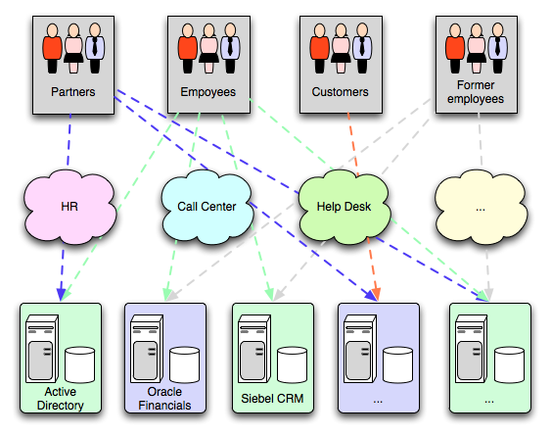Figure 1: No IAM organization
By introducing a complete IAM solution, the situation becomes similar to what shown in Figure 2: the centralized IAM system takes care of all security aspects of the communication between users and applications, synchronizes information among different systems, performs auditing and logging of all the processed transactions – if required.
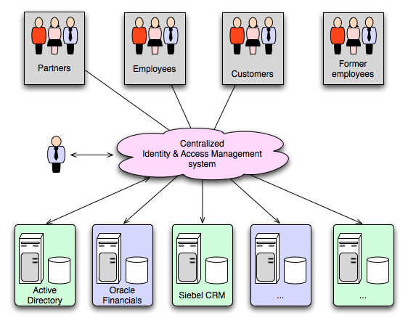Figure 2: IAM-enabled organization

Identity Lifecycle Management
As suggested by what stated above, one of the most important concepts in a successful IAM solution is the processes and technology used to create and delete accounts, manage account and entitlement changes and track policy compliance, including some or all of the following:
- Provisioning / de-provisioning
The automatic creation and expiration of accounts in multiple systems based on data from authoritative data sources, thereby reducing the administrative effort involved in manual account creation and management, and reducing security risk by the automatic application of policies.
- Workflow
The automation of steps within the identity lifecycle management process including notification, approval, escalation and creation of audit data.
- Administration
The facilitation of the administration of identities, usually through the deployment of a web-based user administration console. Such interfaces are often used for delegated administration and possibly even user self-service, in conjunction with workflow.
- Credential management
Passwords, certificates and smart cards.
- Role management
Where Role Based Access Control (RBAC) is in use, facilities for the creation and maintenance of roles, including role definition and role membership.

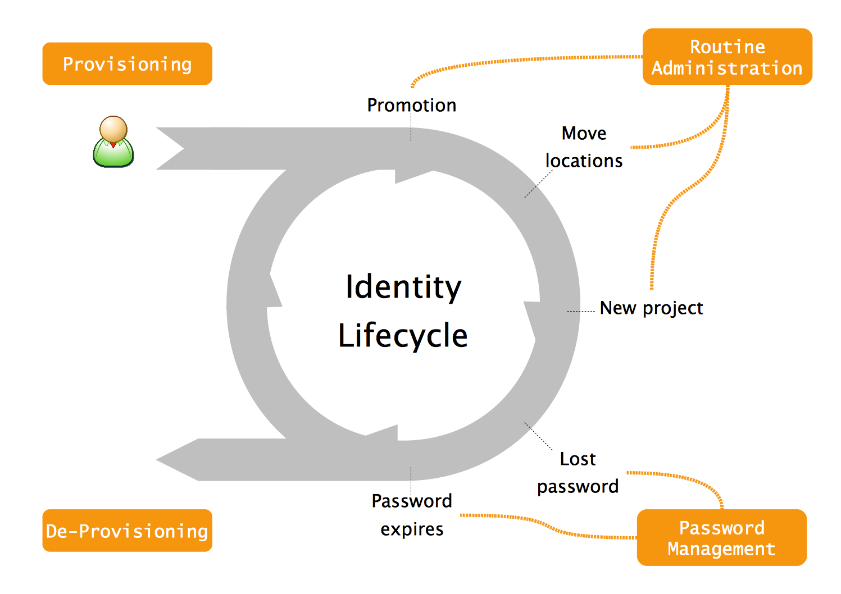Figure 3: Identity Lifecycle

Syncope, Open Source IdM
Syncope (http://syncope.googlecode.com/) is an IdM solution, implemented in J2EE technology and released under Apache 2.0 license (http://www.apache.org/licenses/LICENSE-2.0.html).
Syncope features most of what expressed above in terms of pure identity management. For deployment scenarios in which access management features are requested as well, Syncope perfectly fits together with some Open Source access management solutions, like as OpenAM (http://forgerock.com/openam.html) or CAS (http://www.jasig.org/cas/).
In order to run Syncope, a J2EE container (Apache Tomcat, for example) and a DBMS are only needed. Most of DBMSes available either on the market or in the Open Source space are fully supported.
Syncope source code is at the moment hosted by GoogleCode, versioned with SVN and implemented as an Apache Maven 2 multi-module project. Stable Maven artifacts are regularly published to central repository at http://repo1.maven.org/maven2/org/syncope/, while snapshot releases are available at https://oss.sonatype.org/content/groups/public/org/syncope/.
As many other modern Open Source projects, Syncope is built upon solid foundations, made in turn by other Open Source projects. Some of them are reported below:
- Spring 3.0 (http://www.springsource.org/)
- Hibernate (http://www.hibernate.org/)
- OS Workflow (http://www.opensymphony.com/osworkflow/)
- EHCache (http://ehcache.org/)
- Apache CXF (http://cxf.apache.org/)
- Apache Wicket (http://wicket.apache.org/)
- Identity Connectors (https://identityconnectors.dev.java.net/)
- DbUnit (http://www.dbunit.org/)
- SLF4J (http://www.slf4j.org/)

Why Open Source
People that started Syncope inception and development got all the times stuck in license related issues, mainly about costs and bureaucracy.
They used to be able to successfully draft most of customers needs in terms of middleware, often obtaining very satisfactory results, by only using Open Source systems and tools. All that with a (very noticeable) exception: IdM. Nothing seemed to be found throughout the all Internet that was implementing what needed to fulfil customers' requirements.
At that point it became clear that the only way out was to respond to one of mostly heard sentences in modern IT: “Do you pine for the days when men were men and wrote their own device drivers?” [Torvalds, Linus and David Diamond (2001). Just for Fun: The Story of an Accidental Revolutionary. Collins. Notes: Announcing Linux version 0.02 [ibid]].
So, at the end, why Open Source? Because it's better!

High-level Architecture
From an high-level point of view, the component architecture of Syncope can be summarized by Figure 4. Syncope is composed by two main subsystems:
- the core
The web application that implements IdM features; it offers a RESTful interface for caller applications, implements the provisioning core by mean of its workflow engine and its propagation layer, manages data persistence.
- the console
The web management interface for configuring and administering Syncope core. Like as other external applications, the console communicates with the core by REST calls.

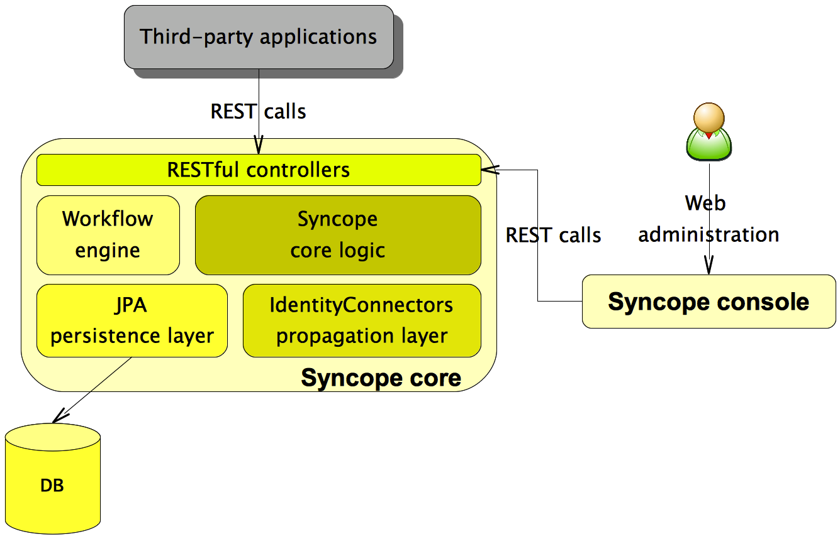Figure 4: High-level Syncope architecture

Syncope core logic
This central component orchestrates the whole data flow throughout the system. Gets involved upon RESTful calls, processes data alongside the defined workflow, persists and propagates to configured resources, if needed.

RESTful controllers
RESTful controllers take care of the communications with outside world. Implemented by leveraging Spring 3.0's REST and MVC features, these controllers exchange data in both XML and JSON formats.

Workflow engine
Syncope supports the definition of an XML descriptor in which user lifecycle is defined. This aspect makes the whole system very flexible to adapt to different situations.

JPA persistence layer
All the data used by Syncope (users, roles, attributes, resources, …) is managed at an high level with a standard JPA approach and persisted to the underlying database.
The chosen JPA implementation – Hibernate – can be quite painfully changed at configuration level to other implementations like as EclipseLink, iBatis or even Oracle TopLink.
This approach makes Syncope to be successfully deployable on most DBMSes without any modification on the source code; in order to have an idea of this possibility, take a look at http://docs.jboss.org/hibernate/core/3.5/reference/en/html/session-configuration.html#configuration-optional-dialects.

IdentityConnectors propagation layer
Identity connectors are designed to separate the implementation of an application from the dependencies of the system that the application is attempting to connect to.
Identity connectors used to be part of the market leader Sun IdM and have been released by Sun as an Open Source project. This makes the propagation layer particularly reliable since most connectors are already implemented in the framework and widely tested; in addition to the ones reported at http://wikis.sun.com/display/IdentityConnectors/Find+a+Connector, some new ones have been included in Syncope source code, like SOAP web-service.
Propagation to target resources can be configured in Syncope to be performed in either synchronous or asynchronous mode, depending on the fact that the propagation result of a given resource is relevant for the whole provisioning process or not.
Propagation operations – a.k.a tasks – are saved for later re-execution.

Console walk-through
Probably the best way to describe the main features of Syncope is a brief walk-through among console's screenshots in order to highlight some of major Syncope peculiarities.
Let's start from the welcome screen (Figure 5), displayed right after successful login; some icons are shown to introduce all console features:
- Schema – here the schema of attributes that will be used throughout the whole system are managed, for users, roles and memberships (a membership is a user / role association);
- Users – user attributes, roles, resources;
- Roles – role attributes, resources and entitlements;
- Connectors – “physical” interconnections towards target provisioning resources;
- Resources – abstraction related to connectors, encapsulating the mapping between data managed by Syncope and data managed by the provisioning resource;
- Tasks – encapsulation of each single provisioning operations;
- Report – useful information about underlying operations;
- Configuration – runtime parameters.
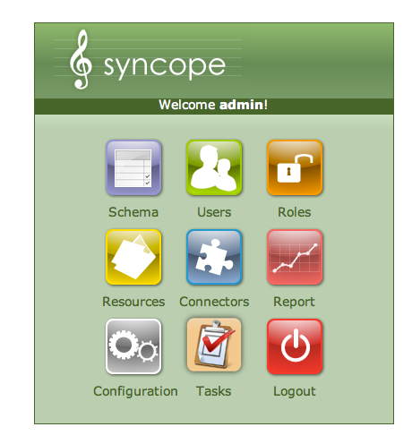Figure 5: Console: welcome screen
Schema are the definition of the type that attributes in the system will have. Schema can be defined for users, roles and memberships. Looking at Figure 6, various elements can be configured for each schema:
- name
- conversion pattern (for non-string values)
- optional validator class
- base type (String, Date, Boolean, Long and Double)
- mandatory condition (an expression defining wether this schema is absolutely mandatory to have values or if this schema is mandatory if other schema are valued)
- virtual (a schema for attributes whose values are not stored in the local repository but directly mapped to one of configured resources)
- multi-value (for attributes with more than one value)
- read-only (for attributes that cannot be modified upon REST calls)
- unique constraint (a schema for attributes with unique value)

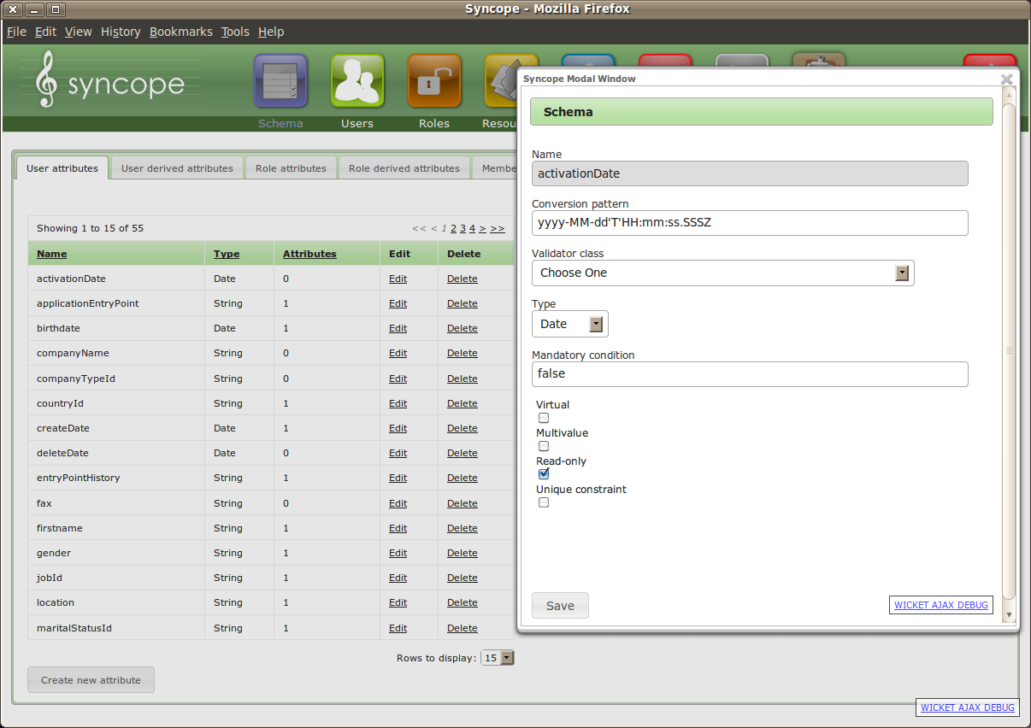Figure 6: Console: schema editing

The system can configure derived attributes as well (see Figure 7) by mean of an expression involving one or more schemas.
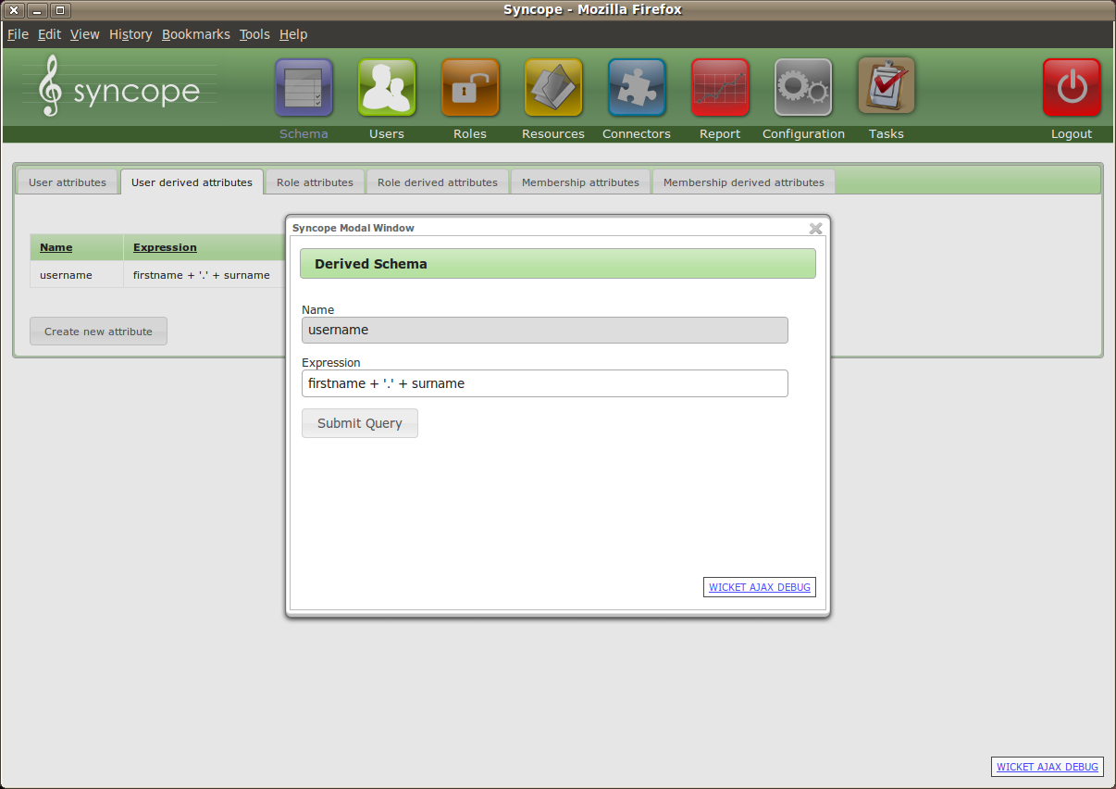Figure 7: Console: derived schemas
Users can be managed by either performing configured workflow actions or going to direct editing of their attributes (Figure 8), resources (Figure 9) or roles (Figure 10).
Users can also be searched upon specification of a condition (Figure 11).
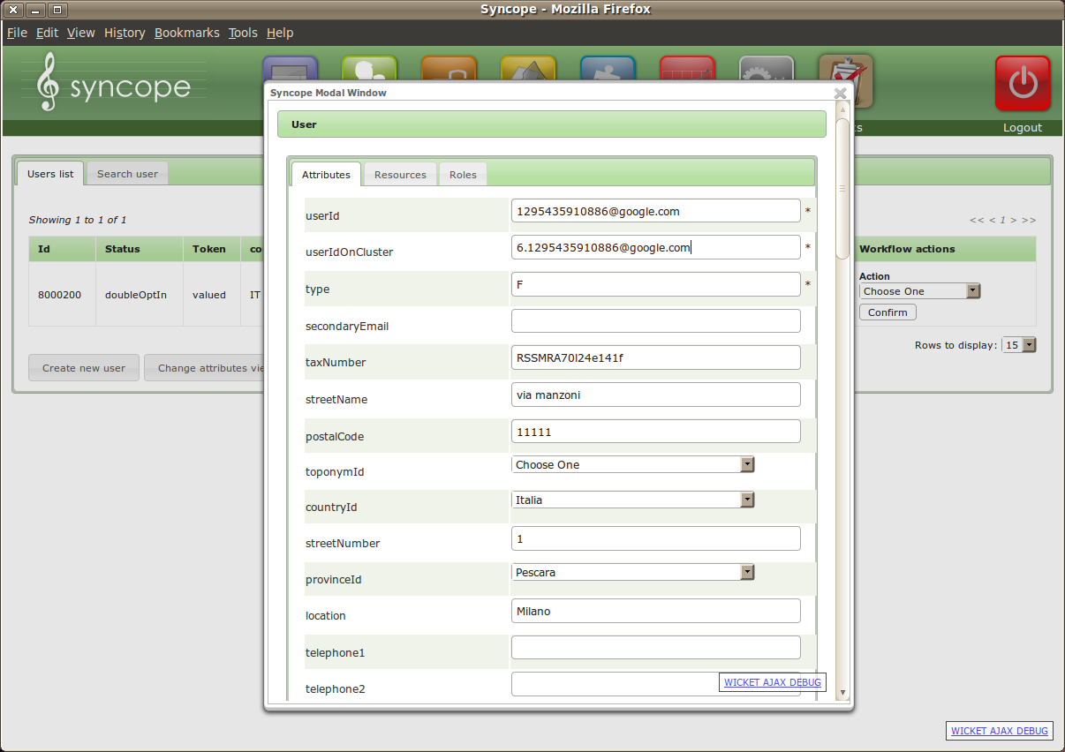Figure 8: Console: user attribute editing
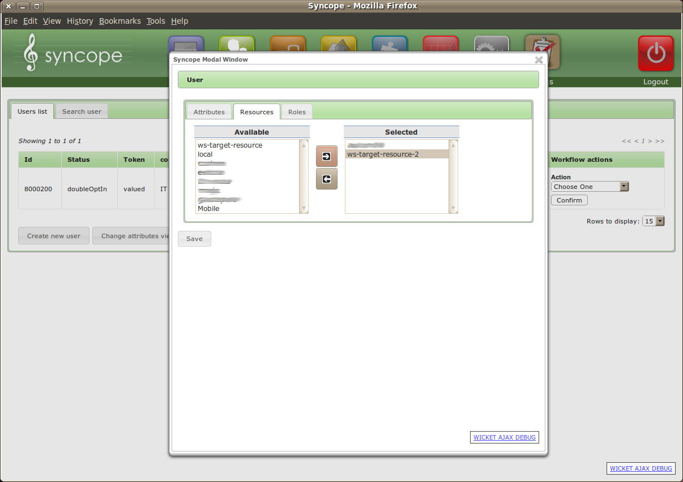Figure 9: Console: user resource editing
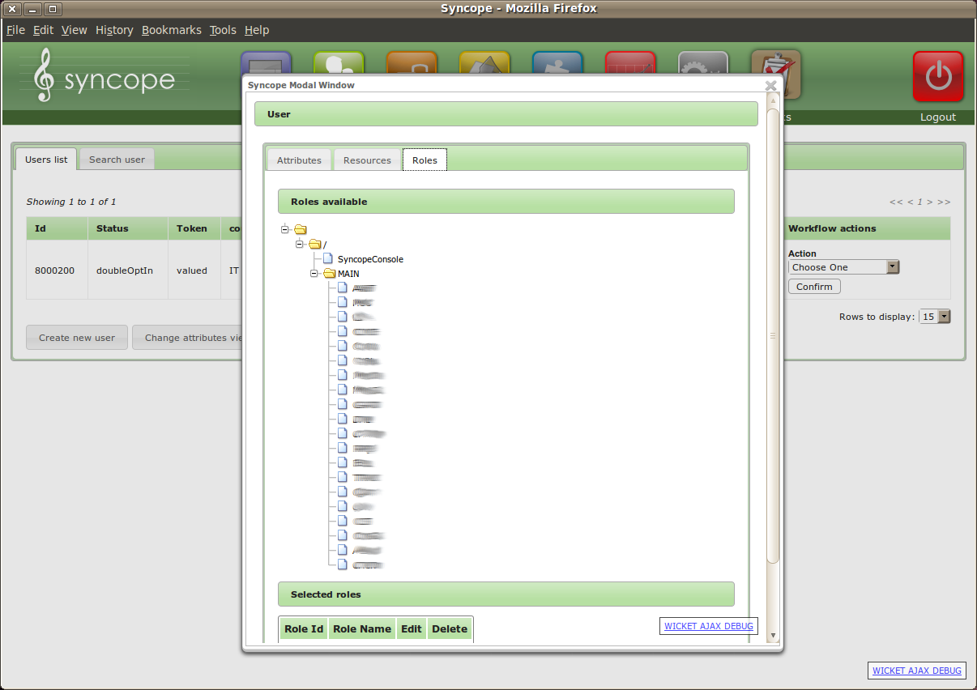Figure 10: Console: user role editing (memberships)
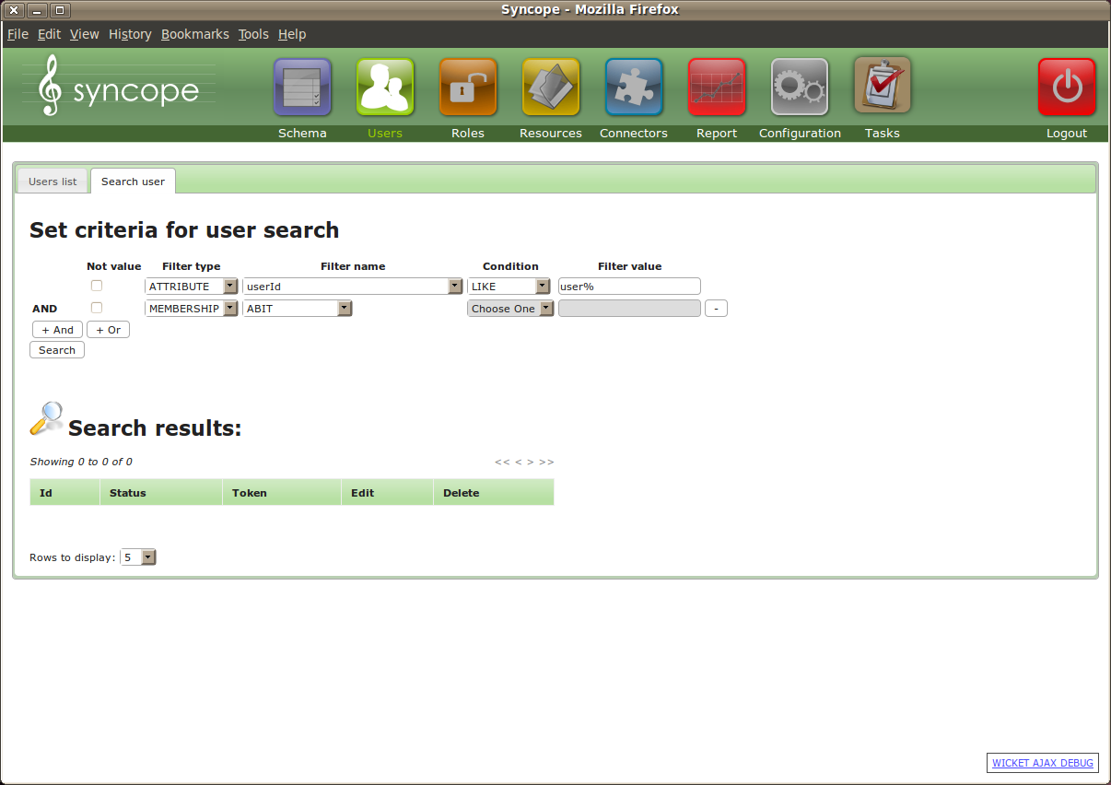Figure 11: Console: user search

Roles can be managed by editing their attributes (Figure 12), resources (Figure 13) or entitlements (Figure 14). Entitlements are used to grant delegated access to a subset of console's features to users, besides the full access granted to super-user (admin).
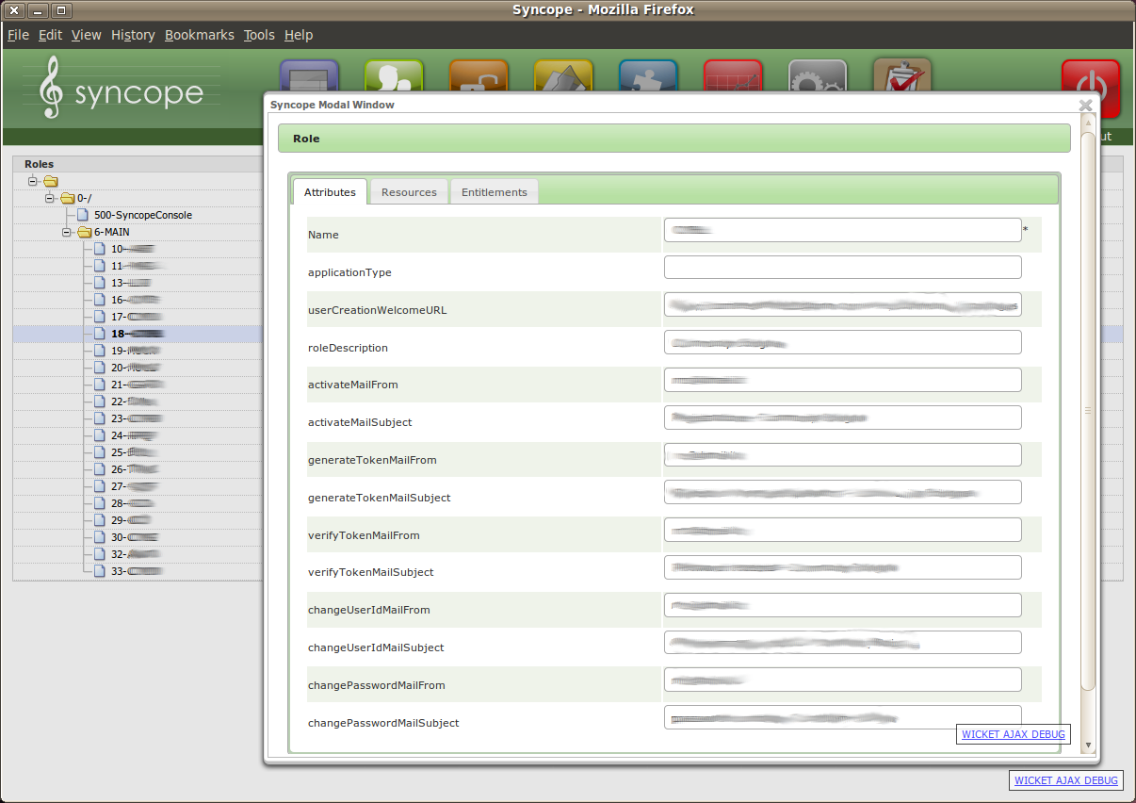Figure 12: Console: role attribute editing
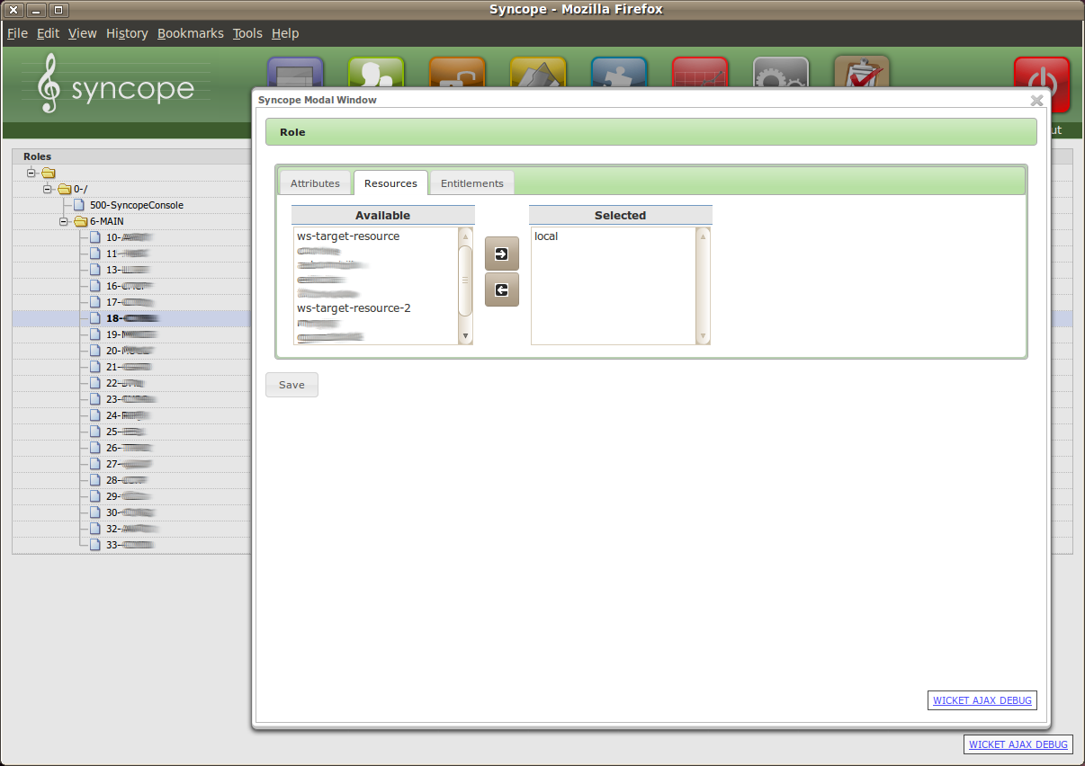Figure 13: Console: role resource editing
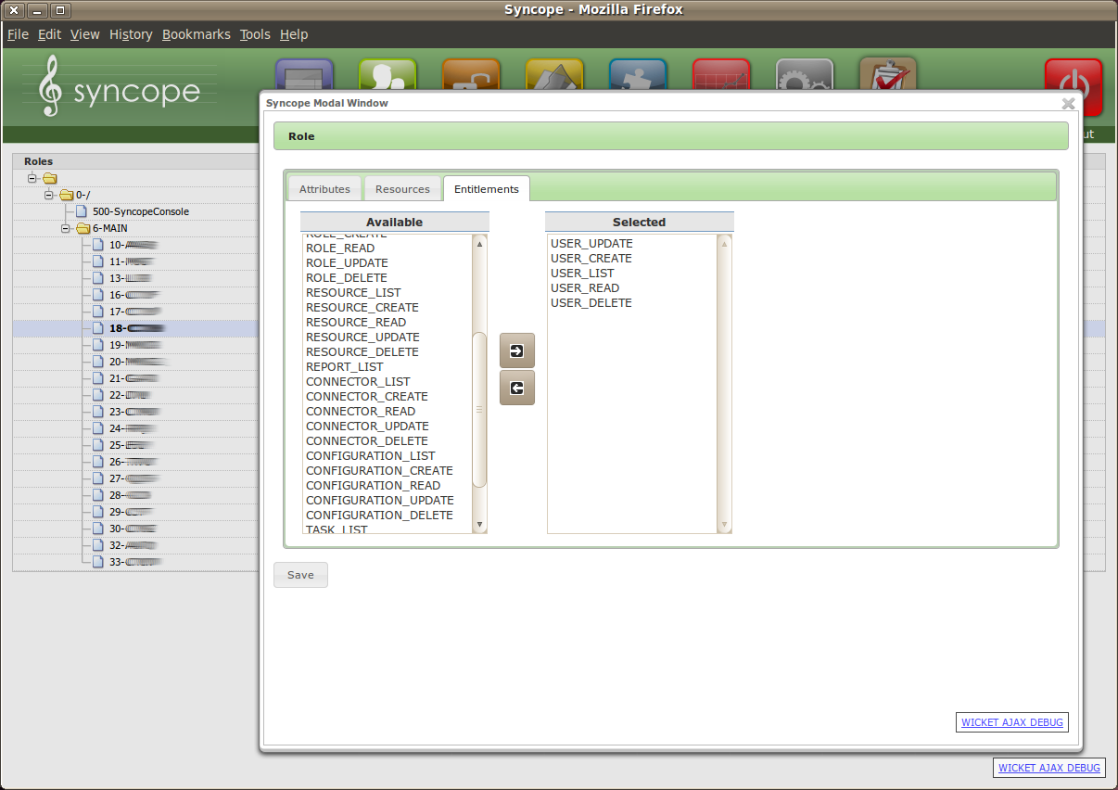Figure 14: Console: role entitlement editing
Connectors are instances from the above mentioned Identity Connectors framework and represent the connections towards specific target resources (LDAP, SQL, SOAP, …); depending on the type of communication, some configuration must be specified (Figure 15). Moreover, for each connector instance some capabilities must be specified as well (Figure 16) to indicate the conditions under which the target resource has to be contacted during the propagation phase.
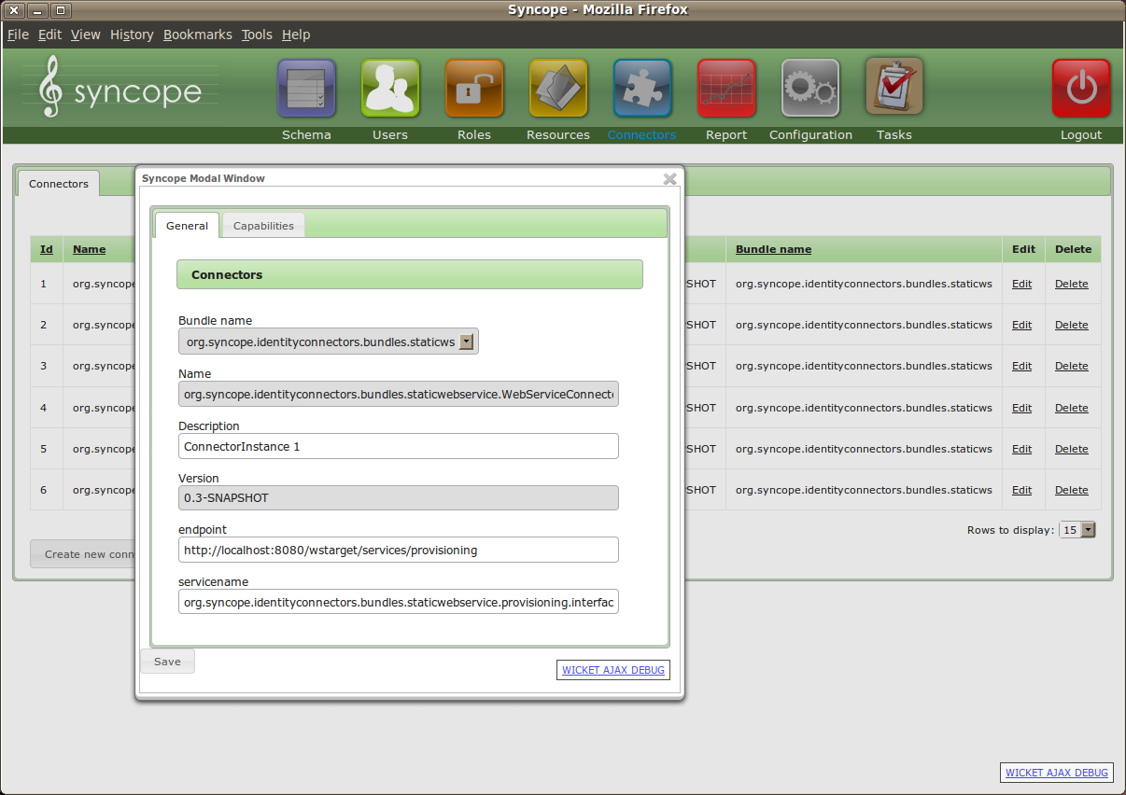Figure 15: Console: connector general editing
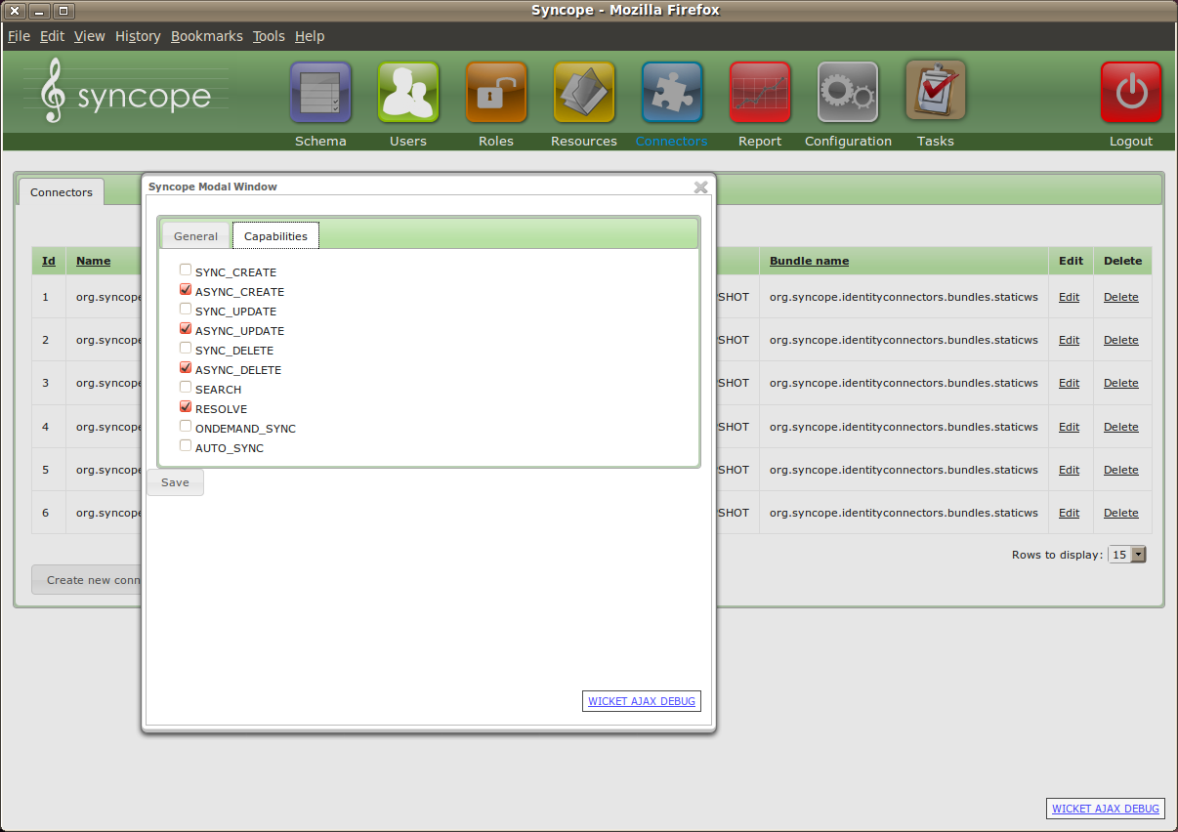Figure 16: Console: connector capability editing

One of the most powerful features is about the mapping between schema defined in Syncope and data owned by target resources. This information is managed via a dedicated widget (Figure 17):
- Source mapping type; it can be one of
  - UserSchema (schema defined for users)
  - RoleSchema (schema defined for roles)
  - MembershipSchema (schema defined for memberships)
  - SyncopeUserId (the numerical distinguished id of each user)
  - Password (user password)
- Schema attribute: if source mapping type is about schemas, the identified schema
- Field: the name of the attribute owned by the target resource
- Mandatory condition: an expression stating wether this mapping is mandatory or not; besides basic “true” and “false”, more complicated conditions can be expressed – for example “type == 'F'” means “this mapping is mandatory if the schema type has value F”
- Account id: wether this mapping is the distinguished identifier at the target resource
- Password: wether this mapping is the password field at the target resource
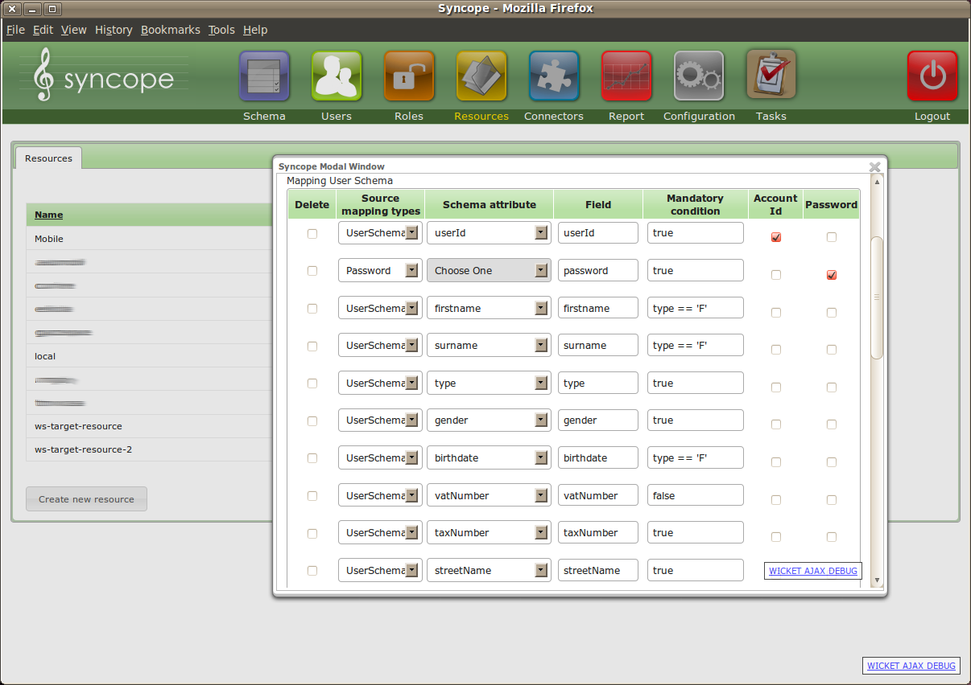Figure 17: Console: target resource editing (schema mapping)

When Syncope, upon REST call, has done everything needed locally, is ready to contact the configured target resources in order to propagate the appropriate data under the conditions previously specified. This kind of information is encapsulated in a task.
A task can be configured to perform synchronously or asynchronously and can be re-executed, if needed. Result of each execution (in terms of status and message) are available (Figure 18 and Figure 19).
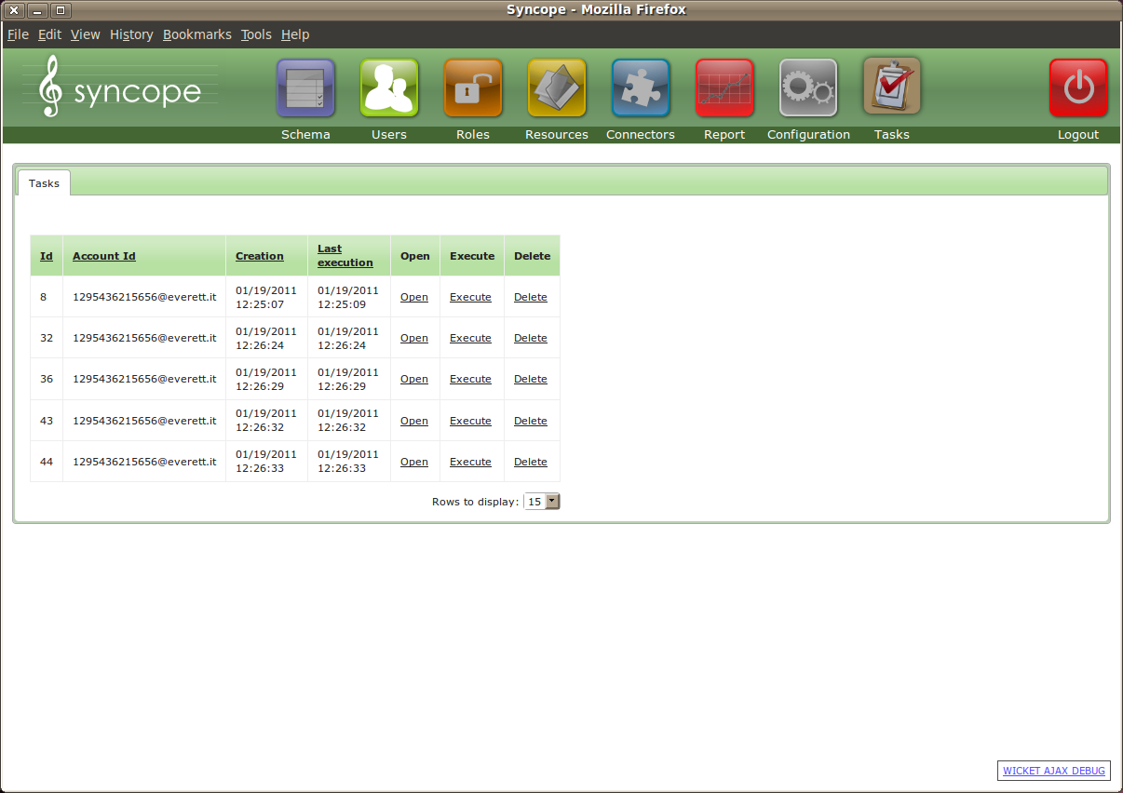Figure 18: Console: task list
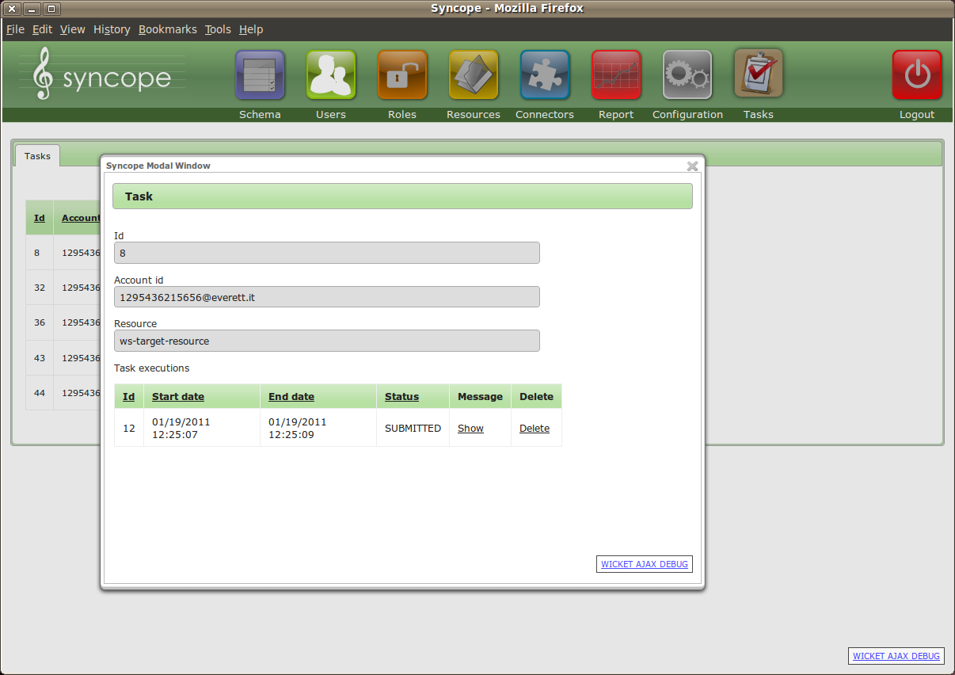Figure 19: Console: task detail
Finally, runtime parameters expressed as key / value can be configured (Figure 20).
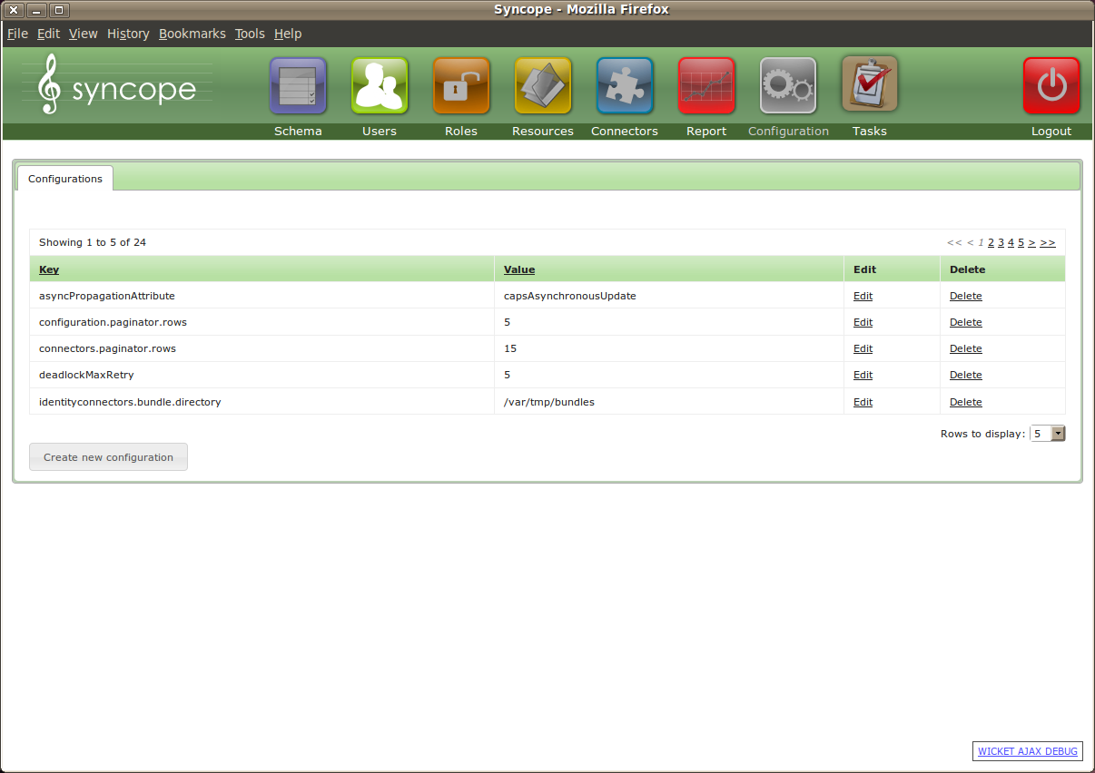Figure 20: Console: runtime parameter configuration

Some achievements
Some relevant facts that have been achieved in more than one environment:
- > 2 million users
- > 50 million user attributes
- 30 roles
- > 3 million memberships
- > 12 million membership attributes
- customized workflow implementation with confirmation sent over as e-mail and SMS text
- customized console
- synchronous and asynchronous SOAP propagation

